Intro to Databases – Lab Report 05
Student Name: Qasim bin Mehmood
Student ID: AS25SYD006
Course: Intro to Databases
Date: June 27, 2026

Submitted to: Prof. Dinakar Bhotta

Table of Contents
3. Insert 10 Documents 3
4. Cursor with For Loop 4
5. Use of Projection with Cursor 4
6. Query Operators 4
7. Upsert 6
8. Datetime Operations 7

1. Create Collection - books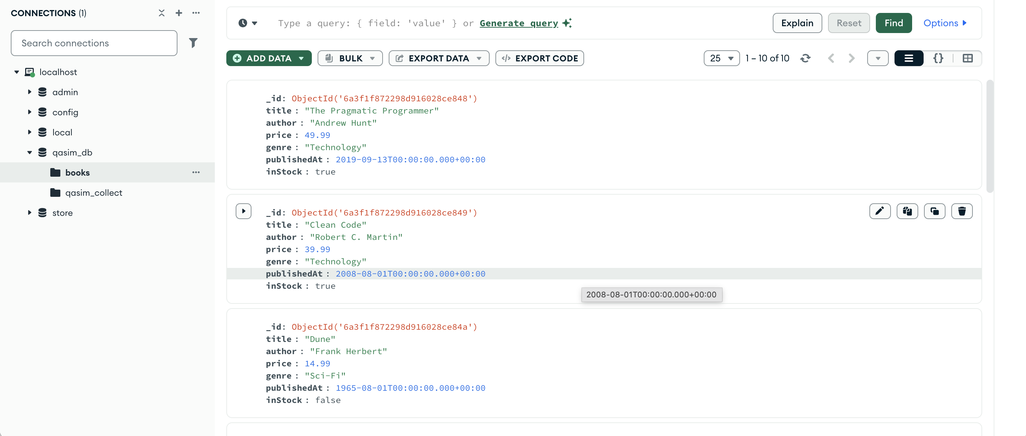

3. Insert 10 Documents
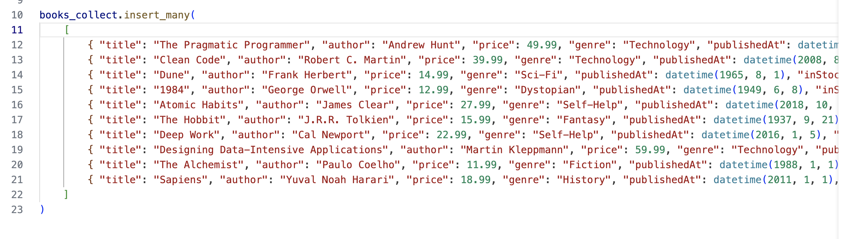
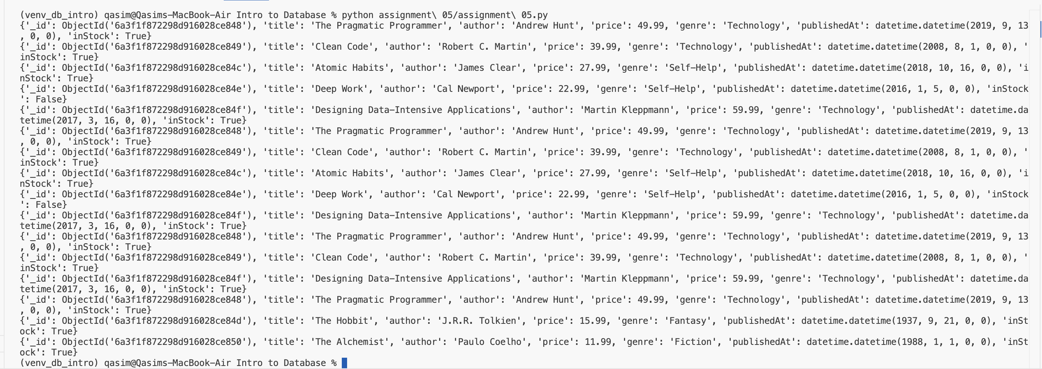

4. Cursor with For Loop
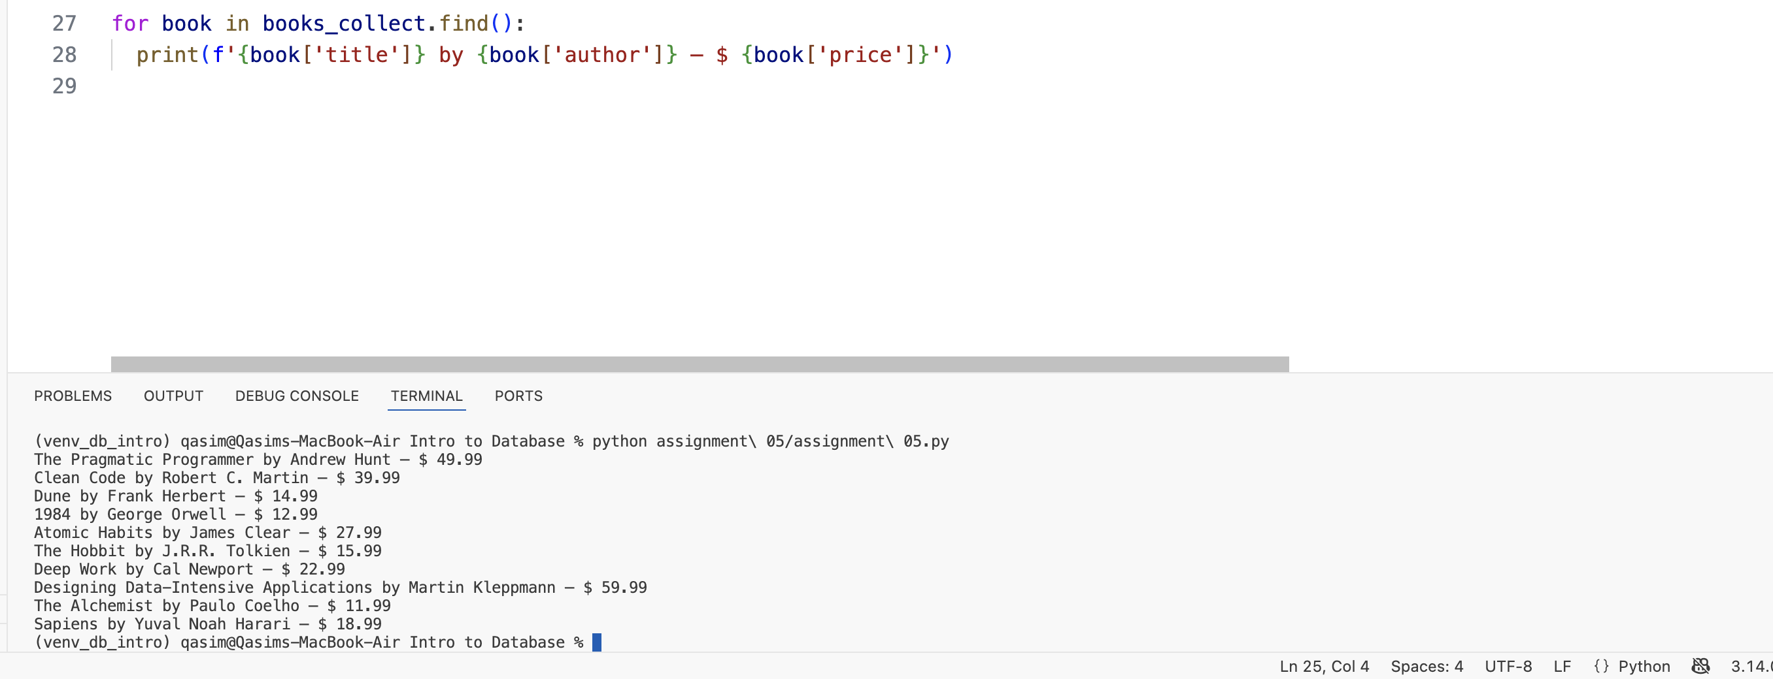
5. Use of Projection with Cursor
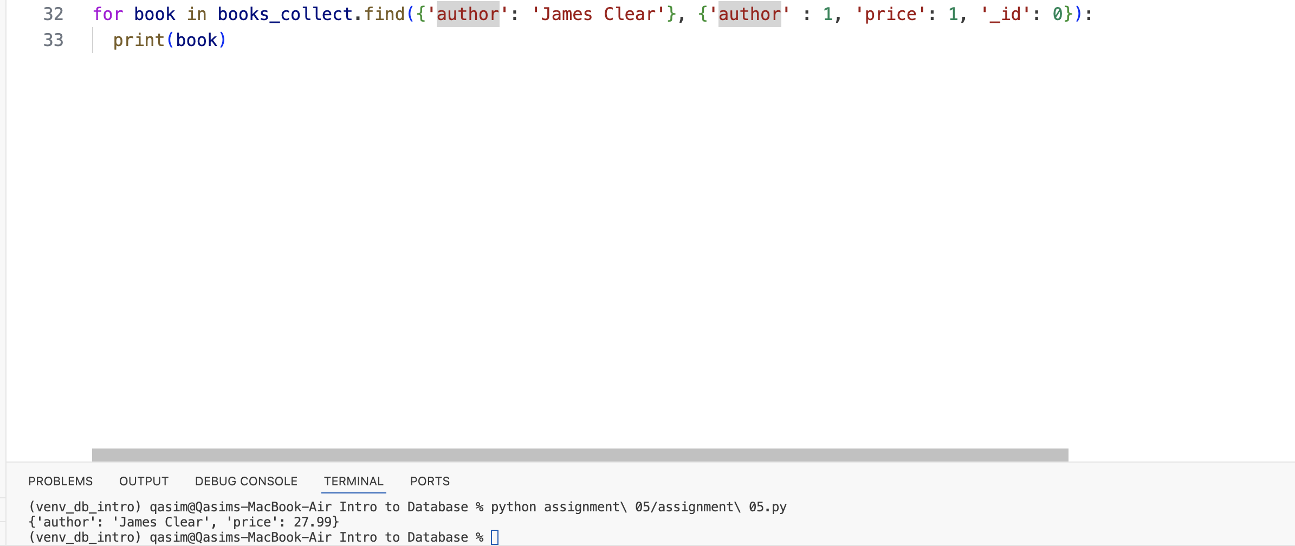
6. Query Operators
# $gt — books priced greater than $20
books_gt = books_collect.find({ 'price': { '$gt': 20 } })

# $in — books in specific genres
books_genre = books_collect.find(
{
"genre": {
"$in": [
"Technology",
"Self-Help"
]
}
}
)

# $and — technology books that are in stock
books_and = books_collect.find(
{
"$and": [
{"genre": "Technology"},
{"inStock": True}
]
}
)

# $regex — books whose title contains "the" (case-insensitive)
books_case = books_collect.find(
{
"title": {
"$regex": "the",
"$options": "i"
}
}
)

for query in [books_gt, books_genre, books_and, books_case]:
for book in query:
print(book)
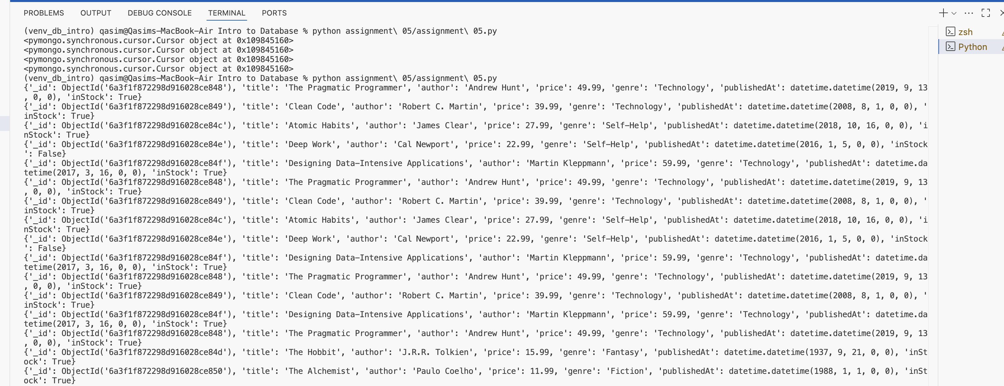

7. Upsert
books_collect.update_one(
{ "title": "The Lean Startup" },
{
"$set": {
"title": "The Lean Startup",
"author": "Eric Ries",
"price": 29.99,
"genre": "Business",
"inStock": True,
"publishedAt": datetime(2011, 9, 13)
}
},
upsert=True
)

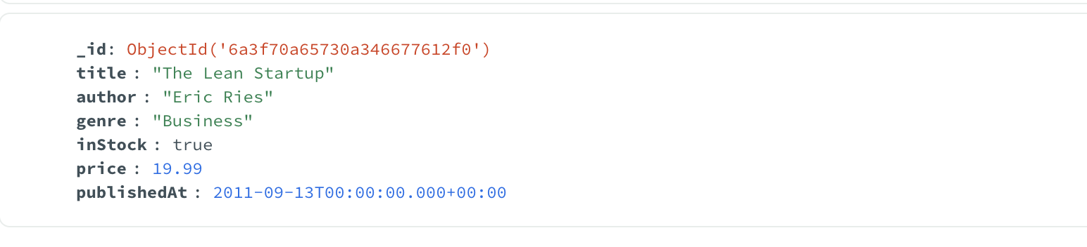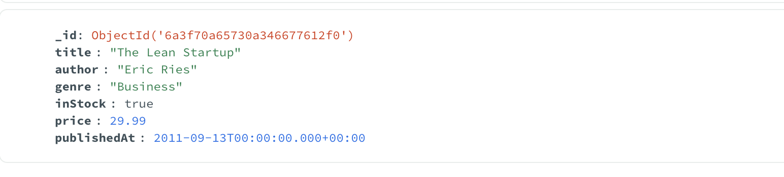
8. Datetime Operations
